Abhijith.V, Akash Shetty, Alan Jacob, Aman Bhat T, Akilesh.S, Harshit.J.Dave, Abdul

Software Engineering

Automotive manufacturing

DESIGN

MANUFACTURING

MACHINING

ASSEMBLY

TESTING & VALIDATION

SALES & MARKETING & MAINTAINCE

DESIGN

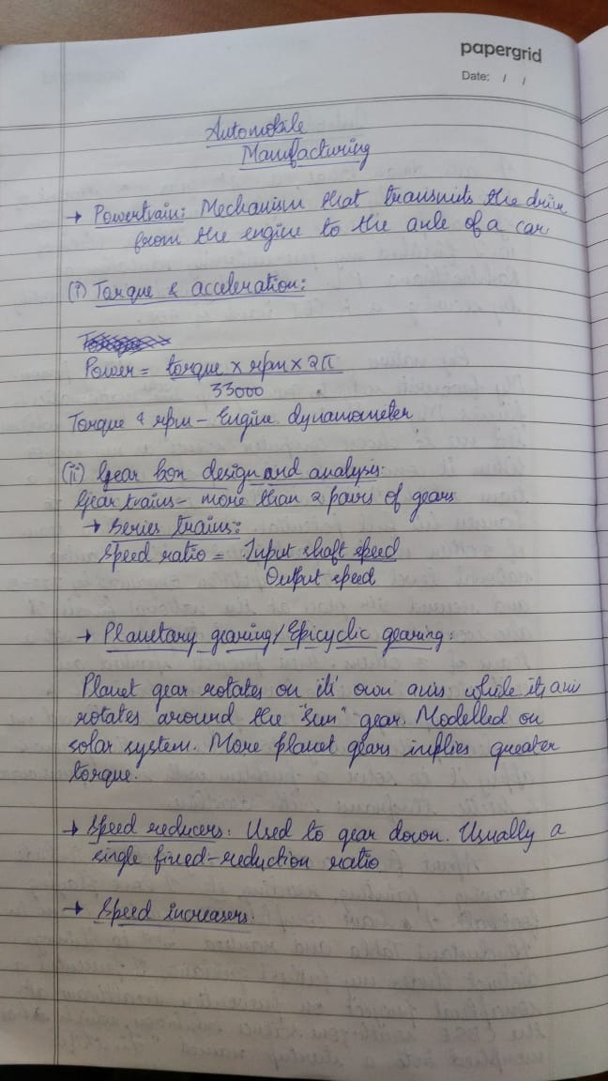

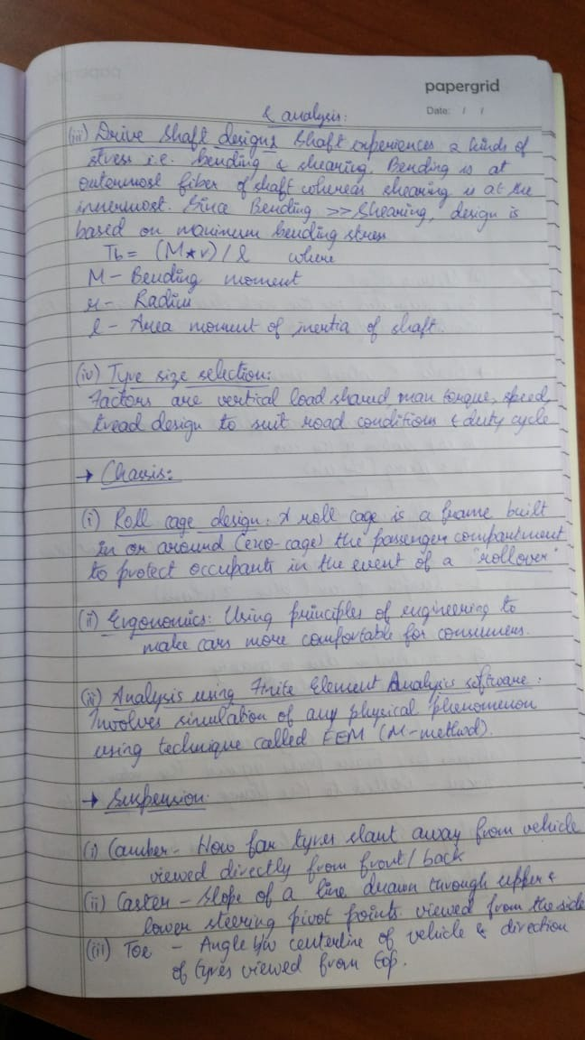

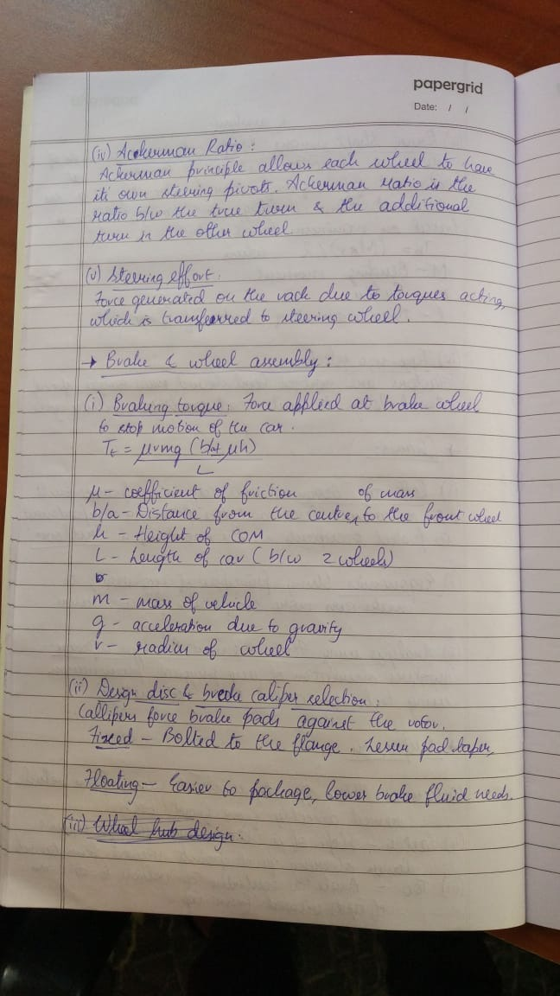

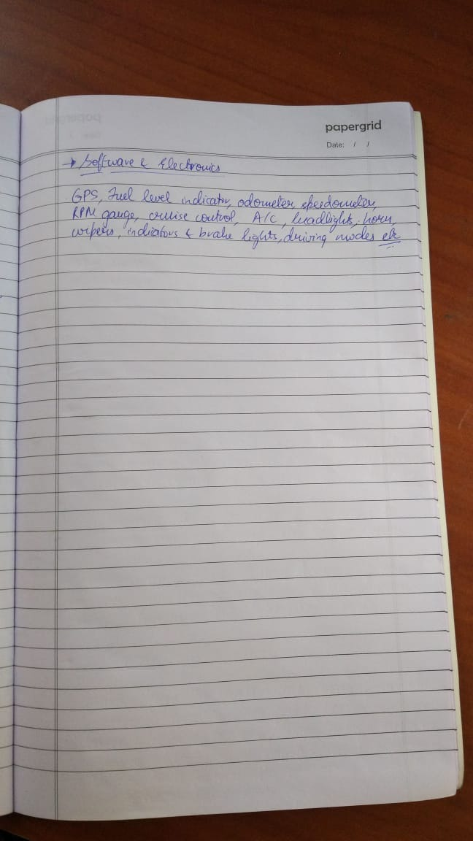

MANUFACTURING

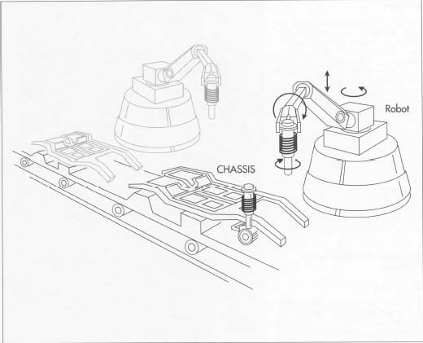

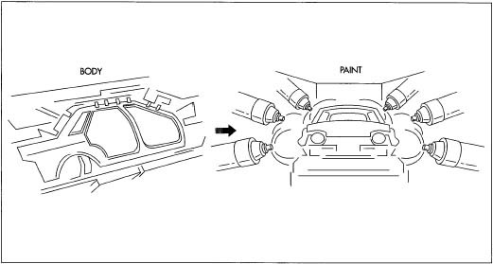

Parametic software.

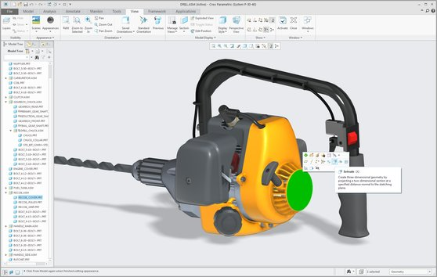

MACHINING

**Machining** is any of various processes in which a piece of raw material is cut into a desired final shape and size by a controlled material-removal process. It is a process not done by the main manufacturing companies(eg.Audi) but by an OEM(original equipment manufacturer eg.Sansera) who makes engine parts, wheel parts etc.

Manufacturing Companies like Audi send their designs and requirements to the OEM Companies to manufacture engine parts, wheel parts etc. This way it is less expensive because there is no need of raw materials to be bought separately and man-power to manufacture the parts.

The steps involved here are:

1)Design

2)Drafting

3)Machining Process

**DESIGN**

Manufacturing Companies like Audi send their designs and requirements to the OEM Companies to manufacture engine parts,wheel parts etc. The design can be done using softwares like Solid Works,Catia ,autoCAD.These Designs will be in 3D Form.

**DRAFTING**

In this method we convert the 3D design to 2D version so that it will be easy for the machinist to manufacture the parts.The 2d diagram of the parts must consist of precise scale and its measurements(here the parts can be gears,bolts etc). We can use AUTO CAD.

**MACHINING PROCESS**

In this phase we have all the processes like milling,drilling shaping,grinding,boring etc,these are the processes used to manufacture a desired part from a raw material. There are automated Machines called CNC(computer numerical control) which does all the process ,all we need to do is write a G-code along with the measurements(programming language for CNC).Before there were seperate machines for each processes which needed a lot of man power,but now everything is automated.

**3D PRINTING**

The present technology for manufacturing these parts is 3D printing.The only requirement here is a 3D design, no need of any processes like drilling,etc But 3D printing a metal part is very costly ,firstly the machine itself is costly secondly it is a topic of on going research.

ASSEMBLY

An assembly line is a manufacturing process in which parts are added as the semi-finished assembly moves from workstation to workstation where the parts are added in sequence until the final assembly is produced.  Skilled workers and robotic systems bring together all of the necessary loose components to create a final product.

Advantages of Assembly line:

1. The primary benefit of assembly lines is that they allow workers and machines to specialize at performing specific tasks.
2. Large-scale assembly lines can allow for mass production of goods that would not be possible if products were made from start to finish by a single worker.
3. ensure a uniform product.

Initial Cost

While assembly lines can potentially reduce the total cost of product per unit, they can have a high initial cost. Assembly lines require a significant amount of space to operate, and renting factory floor space can be expensive. In addition, assembly lines often make use of large, specialized machines that can be expensive to purchase and difficult for small businesses to finance. An assembly line needs to increase productivity and sales enough to cover the initial costs to be considered a sound investment.

Flexibility

Assembly lines are geared toward producing a specific type of product in mass quantities, which can make a company less flexible if it wants to shift production to different types of products. For example, the machinery used on an assembly line used to make automobiles might have little application for other tasks. Shifting operations to produce different products in an assembly line environment can be costly and might require additional training and the purchase of new machinery.

TESTING & VALIDATION

SALES & MARKETING & MAINTAINCE